1.  Untitled  2006  acrylic on canvas  H 228 x 288 cm | 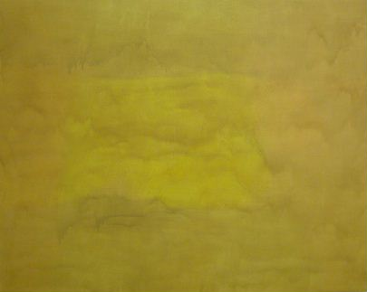
2.  Untitled  2006  acrylic on canvas  H 196 x 240 cm | 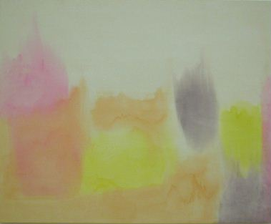
3.  Untitled  2006  acrylic on canvas  H 228 x 288 cm | 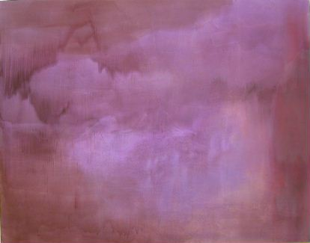
4.  Untitled  2006  acrylic on canvas  H 252 x 374.5 cm | 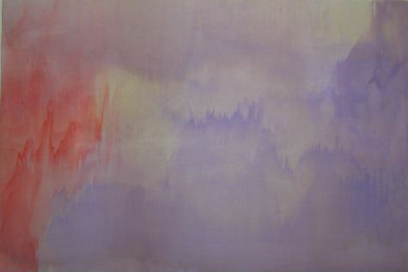
5.  Untitled  2006  acrylic on canvas  H 53 x 53.5 cm | 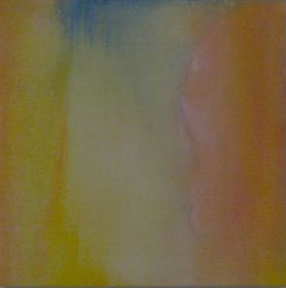

TAKAHIDE KOIKE
“LANDSCAPE IS NOW”

9. Juni – 23. August 2006
AKIRA IKEDA GALLERY / BERLIN

6.  Untitled  2006  acrylic on canvas  H 104 x 78.5 cm | 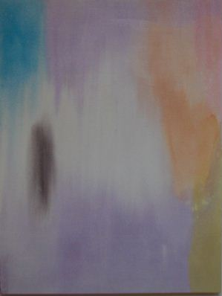
7.  Untitled  2006  acrylic on canvas  H 196 x 260 cm | 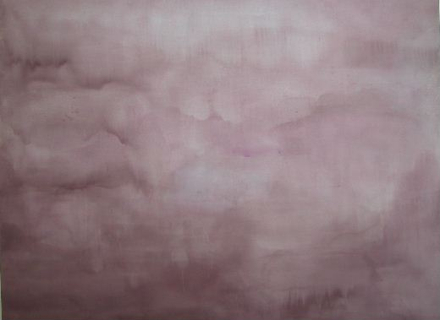
8.  Untitled  2006  acrylic on canvas  H 196 x 240 cm | 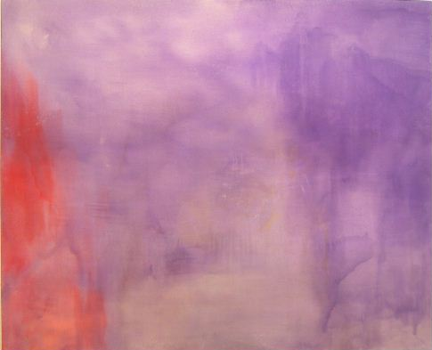
9.  Untitled  2006  acrylic on canvas  H 60.5 x 53.5 cm | 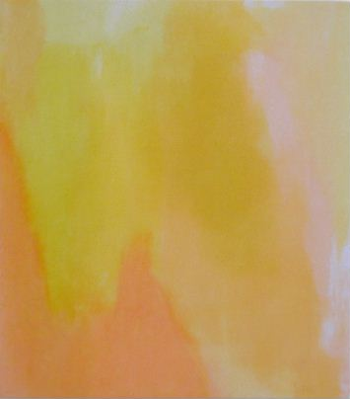
10.  Untitled  2006  acrylic on canvas  H 196 x 173 cm | 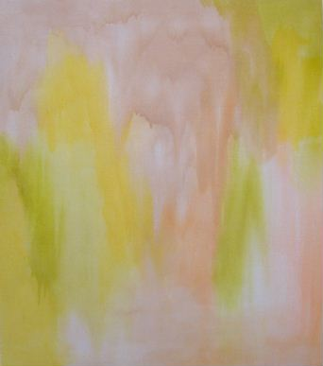
11.  Untitled  2006  acrylic on canvas  H 246 x 244 cm | 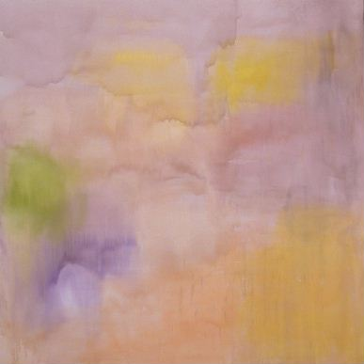

12.  Untitled  2006  acrylic on canvas  H 246 x 244 cm | 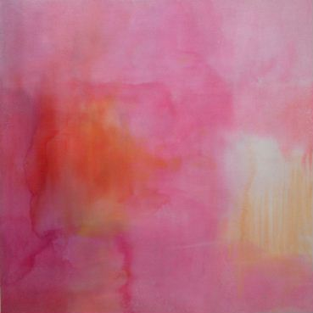
13.  Untitled  2006  water color on paper  each: H 29.7 x 42 cm  framed: H 38.2 x 49.2 cm | 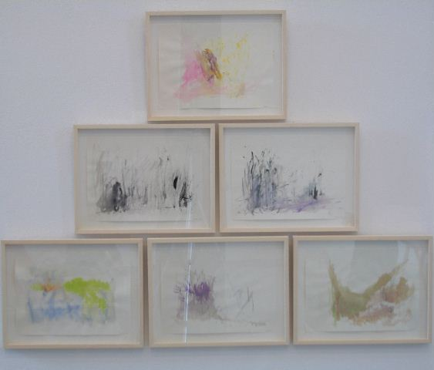  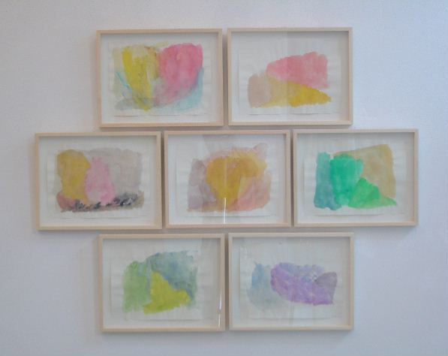  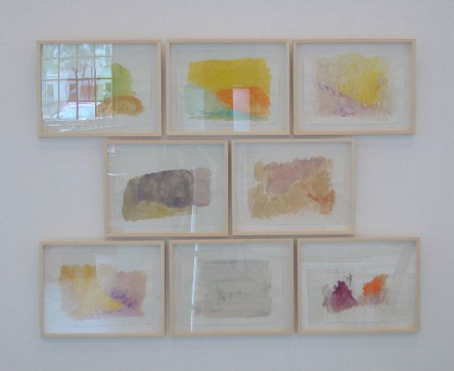
14．  Untitled  2006  charcoal on paper  each: H 30 x 30 cm  framed: H 35.7 x 36.6 cm | 